

Guidelines to create a LinkedIn Profile
LinkedIn is a social platform that connects the world's professionals. A complete LinkedIn profile will summarize your skills to your connections, recruiters, current and future employers.
🎯
Here is how you can create and update your LinkedIn account with your latest skills
1. Creating a LinkedIn Profile
2. Updating your LinkedIn Profile
2.1 Primary Sections
2.2 Building Connections on LinkedIn
2.3 Additional Sections
1. Creating a LinkedIn Profile
Here are the steps to create your LinkedIn Profile:
- Open LinkedIn by clicking here
- If you already have an account log in to it.
- If you don't have an account, you can create an account or signup by using your Google account.
2. Updating your LinkedIn Profile
Here are the steps to update your LinkedIn Profile:
- After logging in, click on View Profile
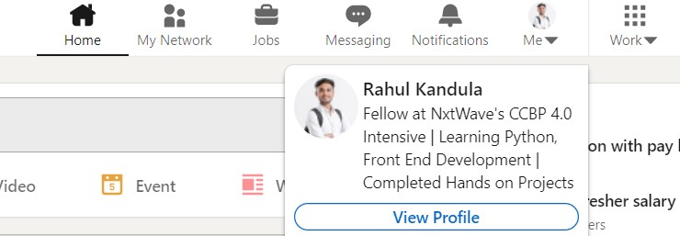
- There will be different sections which are mentioned below. Let's update the primary sections which are essential in building a strong profile
2.1 Primary Sections
- NAME
Your name should be written as: “First Name” “Last Name”
  - First Name: The name that you are known by
  - Last Name: The surname that is shared by everyone in your family
💡
Example
  - Rahul Atttuluri
  - Sachin Tendulkar
  - Sashank Gujjula
🚫
How NOT to add
  - Barbie Bhavana
  - Lovely Priya
  - Raghu Rocks
  - CrAzY ChAiTaNyA
- PROFESSIONAL PROFILE PICTURE
  - Choose a high-resolution image(400x400) that focuses on your face.
Example:

- 🚫
- How NOT to add
  - Avoid side faces.
  - Avoid distracting backgrounds as it will take away the focus from you
  - Avoid taking casual wear in your profile picture. Your Facebook/Instagram Profile Photo may not be appropriate for work
- LinkedIn COVER PHOTO
LinkedIn Cover Photo 1: Click here to download it.

LinkedIn Cover Photo 2: Click here to download it.

- HEADLINE / Bio
💡
Reference
  - Aspiring MERN Stack Developer | CCBPian at NxtWave | Python, SQL, React JS
  - Full Stack Development Trainee | CCBPian at NxtWave | React JS, Frontend Developer
  - MERN Stack Development Trainee at NxtWave | Python, Javascript
🚫
How NOT to add:
  - Don’t write everything in BLOCK LETTERS
  - Don’t write nxtwave, NXTWAVE, NextWave etc.
- EDUCATION
  - Mention your education details in the below order:
    - NxtWave’s CCBP 4.0 Intensive
    - Undergraduate degree (Ex: Engineering/B.Tech/B.E)
    - Intermediate or +2
    - School
  - What to add
    - College Name :
    - Degree :
    - Field of Study :
    - Start year :
    - End year :
NxtWave’s CCBP 4.0 Intensive
💡
Reference
  - School: NxtWave
  - Degree: Fellow at NxtWave’s CCBP 4.0 Intensive
  - Start date: Mention your start month and year
  - End date: Mention your end month and year
  - Description: Learning 4.0 Technologies - Full Stack development
Under Graduation (Ex: Engineering/B.Tech/B.E/B.Sc) :
💡
Reference
  - School: CBIT, Hyderabad
  - Degree: B.Tech (Mention your branch)
  - Field of Study: Electrical Engineering
  - Start date: Mention your start month and year
  - End date: Mention your end month and year
Similarly, add your Intermediate (or +2) & School details
- PROFESSIONAL SUMMARY / ABOUT YOU
  - Imagine that you are having a conversation with your visitors
  - What would you say to someone who wants to know more about you?
💡
An aspiring MERN stack developer. Core strengths include Coding, JavaScript, Python, ReactJs, etc. I'm a quick learner and I have very good problem-solving skills.
💡
At NxtWave’s CCBP 4.0 Intensive, I’m currently learning fullstack development with a specialization in 4.0 technologies. In love with the coding challenges and hands-on projects. With Industry’s first ever IRC 4.0, getting ready to take on new challenges in the tech world.
Tools to customize above content
    - wordtune.com
    - peppertype.ai
- EXPERIENCE(If you have any)
You should write your experience from the latest to the first. (Reverse chronological order) in the given format
  - Title:
  - Employment Type: Full time / Part-time
  - Start date:
  - End date(If you're currently not working in the mentioned organization):
  - Location:
💡
Reference
  - Title: Software Development Engineer
  - Employment Type: Full time / Part-time
  - Start date: Aug 2020
  - End date(If you're currently not working in the mentioned organization): September 2020
  - Location:
After we build the essential primary sections, it is very essential to increase your connections on LinkedIn.
2.2 Building Connections on LinkedIn
- 2.2.1 Customizing your URL on LinkedIn
Customizing your URL to your name will make it easy to share and remember
linkedin.com/in/adkesoxfd -> linkedin.com/in/rahuls
To customize URL
  - Click the Me icon at the top of your LinkedIn homepage.
  - Click View profile
  - Click on Edit public profile & URL from the side menu
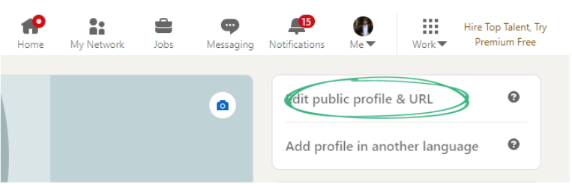
- 2.2.2 Increase your connections on LinkedIn
🚀
Just like how you Add friends on Facebook, you can Add connections on LinkedIn. You can send connection requests to people you know, your seniors, your college mates & your friends.
  - Having a good number of connections improves your professional network. It will help you to get good job opportunities, referrals from companies, etc.
🚀
Generally, 500 connections on LinkedIn is considered to be a good professional network.
  - It is important to have diverse connections on LinkedIn. If you are connecting only with students from CCBP 4.0, your profile might not be visible to recruiters/companies. So, it is very important to connect with people from various companies, your seniors, your friends, etc.
🔎
You can also search for people using the search feature available on LinkedIn
  - Connection requests with a personal note have higher acceptance rates
💡
Reference for Personal Note
Hi, I am a fellow at NxtWave's CCBP 4.0 Intensive, I am passionate about technologies and currently learning and developing skills to become a Full Stack Developer. Would like to connect with you !
Tutorial on how to effectively find people and add connections: Click here
- 2.2.3 Challenge
Challenge: Add at least 10 Linkedin connections weekly for the next few months. Within a few months, you will have a very good number of connections.
Build your professional network now!
2.3 Additional Sections
- SKILLS
Click on Add Section in your Profile Page and click on Skills to update your skills in LinkedIn. You can add the skills that you have gained with CCBP 4.0 and also any prior skills that you have before.
💡
Example Python, HTML, CSS, JavaScript, React JS, Node JS, SQL etc..
- INTERESTS
You can follow interested people, companies, organizations. Here are some of the Companies that you can follow
NxtWave: https://www.linkedin.com/company/nxtwavetech/
Google: https://www.linkedin.com/company/google/
Microsoft: https://www.linkedin.com/company/microsoft/
Also, follow the following hashtags:
#CCBP: https://www.linkedin.com/feed/hashtag/ccbp/
#Nxtwave: https://www.linkedin.com/feed/hashtag/nxtwave/
- OpenToWork
You can let recruiters and your network on LinkedIn know you’re open to new job opportunities with the #OpenToWork feature.
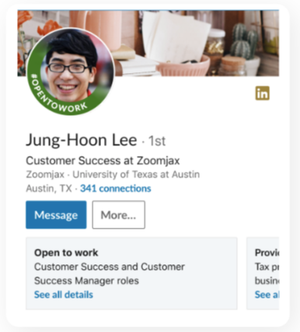
Tutorial on how to enable #OpenToWork feature: Click here
📢
Keep Hiring Team Updated
If you receive any message from a recruiter or a company on LinkedIn, please share the details in the form here: https://forms.ccbp.in/linkedin-opportunites Our hiring support team will guide you on how to how to crack the interview for that company.

